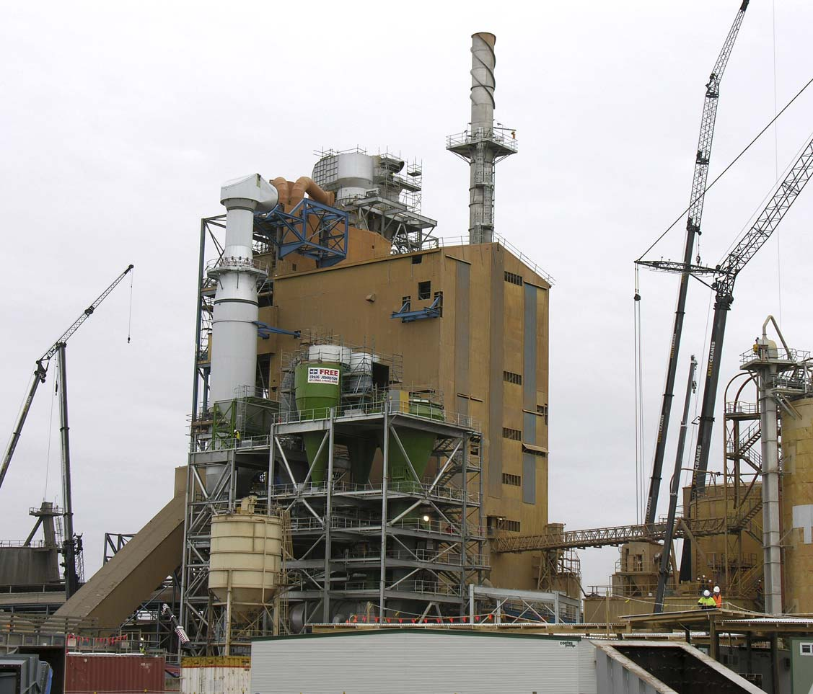
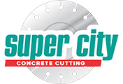
Blue Circle Southern Cement, Victoria

Blue Circle Southern Cement, Victoria

Service Focus

Controlled Demolition Aids Cement Plant Upgrade Down Under

Giant Pre-Heater Vessel Dismantled with Wire Sawing, Hydraulic Splitting
Client: Blue Circle Southern Cement Geelong, Victoria
Contractor: The Engineering Company Somerset, Tasmania / Super City Concrete Cutting Ocean Grove, Victoria

Methods Used: Wire Sawing, Core Drilling, Wall Sawing, Hand Sawing, Hydraulic Splitting Project Date: Dec 2005

Australia’s Blue Circle Southern Cement in Geelong, Victoria is one of the largest cement manufacturing plants in the Southern Hemisphere and is also one of the most environmentally sound. It operates on an alternative fuel program based on the world’s best practices and can process up to 550,000 tons of raw material each year. If Blue Circle was to keep pace with increasing demand for cement products, a major upgrade of the facility would be needed by the end of 2005 to increase processing capacity to 800,000 tons per year. The plant was originally built in the 1960s and had several upgrades since then. For the newest renovation, the facility would be shut down so several areas could be completely rebuilt to allow for the replacement of a number of key processing elements with state-of-the-art equipment.
One of the existing components to be removed was a pre-heater structure used in the combustion of raw materials. CSDA member Super City Concrete Cutting of Ocean Grove, Victoria was contacted by the general contractor, The Engineering Company of Somerset, Tasmania, in August 2004 to design a work program and method that was suit- able for the controlled demolition of the pre-heater structure. Due to the confined access of the work area over.
several levels of the building, as well as the design of the pre-heater vessel, it was decided to use diamond wire sawing to separate the structure.
The pre-heater vessel was made from 16-mm (3/5-inch) thick steel plate and insulated with a 200-mm (8-inch) thick refractory lining. The Kergun AK 419sr refractory consisted of a corundum aggregate with a chemical composition of aluminum, zinc and silicon (sand). The refractory was suitable for casting or shotcreting and had an operating service limit of 1,650 degrees Celsius (3,000 degrees Fahrenheit). The refractory was bonded to the inner steel casing of the preheater vessel by stainless steel tie bars at 150 mm (6-inch) centers. The strength of the refractory varied through- out the levels with most sections averaging 120 mpa. The preheater vessel was seven floors or 55 M (180 feet) in height and the shape of the vessel was generally rectangular with changing angles averaging 3 M (10 feet) by 5-1/2 M (18 feet).
Super City had recently completed a wire sawing project at an Alcoa Smelter plant in Victoria that required them to wire saw through a solid aluminum block 2,000 mm (6-1/2 feet) wide and 250 mm (10 inches) thick. The results from that project allowed

them to confidently set production rates based on the fact that the refractory material in the pre-heater vessel was made from a high percentage of alumina and silicon which was similar to the material cut at Alcoa.
To verify their production rates, Super City completed a test on a section of refractory material supplied to them by the client. During this test, they also experimented on the material with their hydraulic splitting system to see what effect their splitting system would have. The splitters were so effective in separating the material that Super City modified their work plan to include the use of the hydraulic splitting system.
In February 2005, Super City Concrete Cutting was awarded the contract to demolish and remove the pre-heater vessel. They began work in April 2005, supplying operators for day and night 12-hour shifts with seven operators per shift. Each shift supervisor coordinated the day’s activities based on the con- tract work plan.
Removal of the pre-heater vessel was to take place over five levels of the pre-heater building, Levels 3, 2, 1, mezzanine and ground. The pre-heater vessel was connected at the mezzanine level to the inside chamber

Blue Circle Southern Cement, Victoria

“Safety was an important issue on this job. Before starting work, Super City personnel had to complete Blue Circle’s general
and site specific training. Specific site hazards, restricted areas and lock-out procedures were a major focus of this training.”
B. Kerri son, Project Manager, The Engineering Company

of the kiln connecting up through Level 3 to the cyclone unit of the plant. The cyclone vessel was designed to draw radiant heat generated from production through the kiln up into the pre-heater vessel and onto the filtering and cooling towers to disperse into the atmosphere. Attached to the pre-heater vessel throughout these floor levels were a number of redundant chutes, pipes and access landings, all of which had to be removed. Super City assisted in this additional work using a variety of splitting and wire sawing techniques.
The removal process was to start at the top of the pre-heater on Level 3 and finish at ground level. Each section was to be removed back up through the Level 3 opening and transported by an internal gantry crane onto a fabricated landing attached to the perimeter of the building on Level 3. Assisting in the removal process, boilermakers assigned to Super City cut through the 16 mm steel plate of the pre-heater. Section sizes were limited by weight and existing access through each floor level.
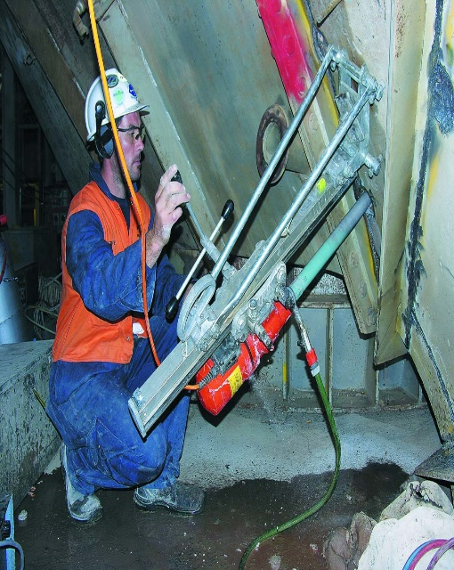
Operators core drilled 250 holes
measuring 48 mm (2 inches) in diameter through the pre-heater vessel with Hydro stress DK 32 and DK 12 and Hilti DD200 core drills in order to use their hydraulic splitting system. Approximately 80 percent of the holes were completed using a rig and base or the Dimas Gyro 40 and Gyro 50 drill stands. The remaining 20 percent were completed by hand due to access and entry restrictions. Holes were positioned in a pattern appropriate for the size of the section to be removed by hydraulic splitting. The average time to drill one hole with a stand was about 10 to 15 minutes. Holes drilled by hand averaged 40 minutes with some taking up to 80 minutes due to the 120 mpa strength of the refractory material.
Upon completion of the core drilling, operators set up a wire saw on top of the pre-heater on Level 3. The wire saw would make two cuts through the vessel creating a 4-ton section in the shape of a wedge. Set-up time was 120 minutes per cut while actual sawing time was 25 minutes. Two different wire saws, a Hydrostress SK-SD and SB, were used during this process. This wedge was then removed back up through

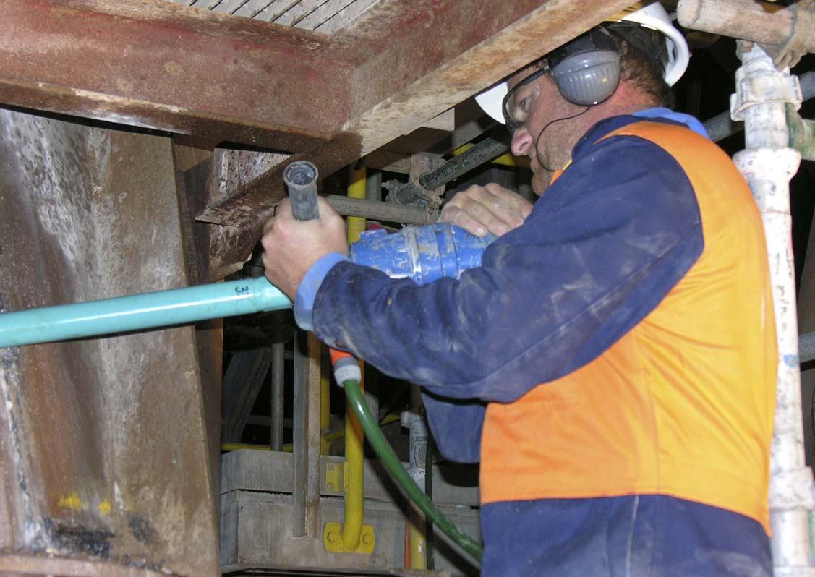

the Level 3 opening and lifted by an internal gantry crane onto a fabricated loading platform attached to the building on Level 3. Super City supervisors and riggers moved it to ground level.
With the first section removed, operators were able to rely on hydraulic splitting for the rest of the pre-heater demolition. The splitting system included Darda C12 and C9 cylinders and Darda HCB6 combi shears. When using any splitting system, the ideal situation is to have or create a space which provides clearance for the cut section to be removed. Wire sawing and hydraulic hand sawing enabled the operators to create the required space needed for efficient removal, saving much time and money.
Both day and night shifts were on schedule as much time was saved with the introduction of the hydraulic split- ting system. When they reached the inlet chamber of the kiln on the ground level, they had removed 35 sections of the pre-heater vessel. The average weight of each piece was 4 tons with the heaviest weighing 8.2 tons. In all, they had removed a total of 160 tons in fourteen

12-hour shifts. Pre-heater removal was completed in May of 2005. Operators encountered complications on Levels 1 and 2, where the pre-heater vessel had two stainless steel expansion joints attached to it. The original work plan to cut each joint into quarters was no longer permitted because traces of asbestos and other materials had recently been discovered inside the joints. This created some concern over how Super City could remove the section in one piece with- out breaking the joint. As there were no other alternatives, Blue Circle engineers decided to remove the expansion joint in one piece. The two expansion joint lifts proved to be the most challenging part of the project. Each joint weighed 8.2 tons and had a tight clearance of 35 mm (1-1/4 inches) to clear the existing floor opening on Level 3. Due to limited access, the section joints had to be rigged off- center, making the removal process extremely awkward.
As an addition to their contract, Super City also removed a horizontal section of concrete from the top of Pit 4, which supported the kiln. Super City thought this task would take only one shift, but unforeseen problems delayed the task. When operators attempted to place their wall saw track anchors into the walls, they found that the existing concrete reinforcement was severely damaged, probably because it had been exposed to water over the years. Blue Circle removed the perimeter reinforcement along the internal face of the pit wall so that Super City operators could set up a wall saw.

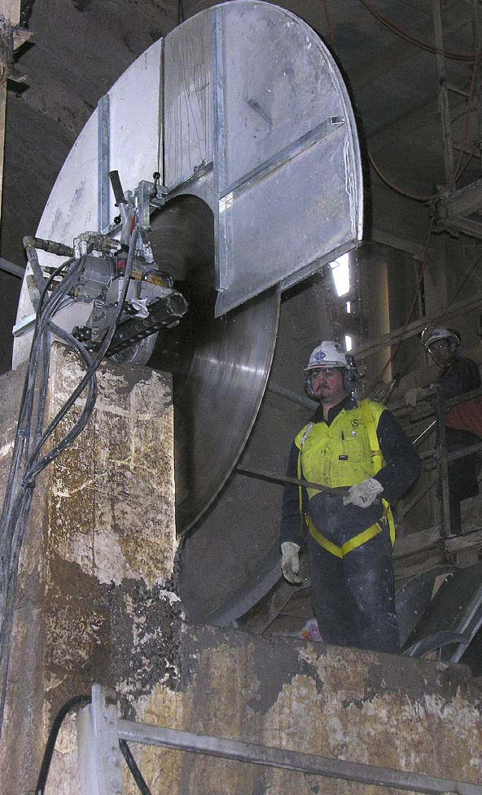

Super City then wall sawed two vertical cuts, each 700 mm (2-1/4 feet) deep, using blades ranging from 1,000-1,600 mm (39-63 inches) in diameter, along the face of each pit wall. Then they jack-hammered away the concrete to expose the damaged reinforcement so repairs could be made.
Safety was an important issue on this job. Before starting work, Super City personnel had to complete Blue Circle’s general and site specific training. Specific site hazards, restricted areas and lock-out procedures were a major focus of this training. Informal toolbox meetings conducted by site managers from each subcontractor on site were held at the start of shift. General safety, the day’s activities and other site issues were discussed, and all personnel had to sign an attendance log to prove they were present. All workers entering the pre-heater building had to place their personal safety lock and identification tag onto the job site’s main lock-out board. This system allowed the site safety wardens to determine how many individuals were operating in the pre-heater building and who they were in case of an emergency or evacuation alarm.
Super City provided a job safety analysis report for each sawing, drilling, splitting and rigging activity they completed. A comprehensive risk assessment was compiled for every plant resource or item Super City planned to use as well as for operating procedures and safe work methods.

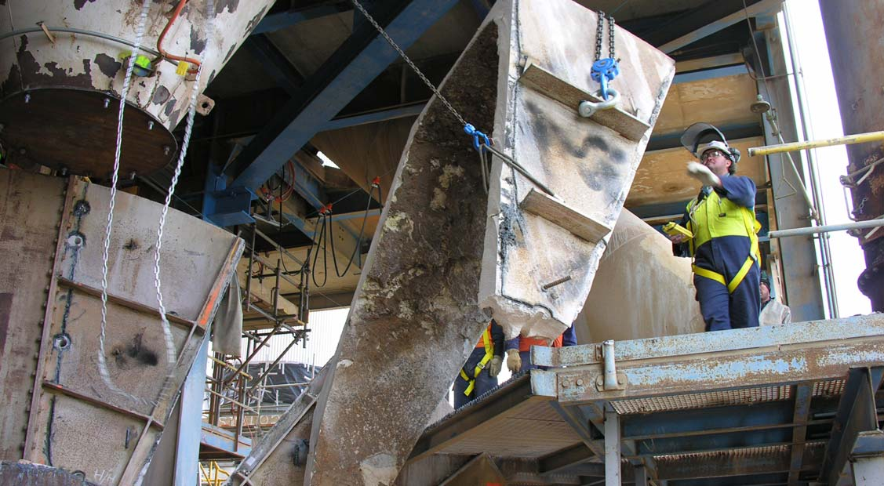

Eighty percent of cutting and removal work was done at a height or within an area that required fall protection so opera- tors working in these areas used fall protection harnesses attached to a certified fall-arrest system. The area where the pre-heater sections were loaded had a security fence and four spotters present during all lifts to ensure safety.
Jason R. Franken, director of Super City Concrete Cutting, said he was very pleased with the outcome of this job. “Shut down work is always difficult because of deadlines and other trades working in close proximity. We were able to safely finish our job in the time allotted while allowing other construction work around the plant to continue,” Franken said. He said the fact that their controlled demolition would not interfere with other plant construction was a major factor in Super City being awarded the contract. The initial job research and materials testing also reassured the client of Super City’s commitment and ability.
In the process of successfully completing this project, Super City not only facilitated plant improvements but also educated the plant owner and general contractor about the capabilities of controlled demolition using diamond tools and precision sawing methods. All involved with the project now have a better understanding of what specialized concrete cutting can achieve in the most challenging work environments.

