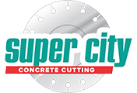

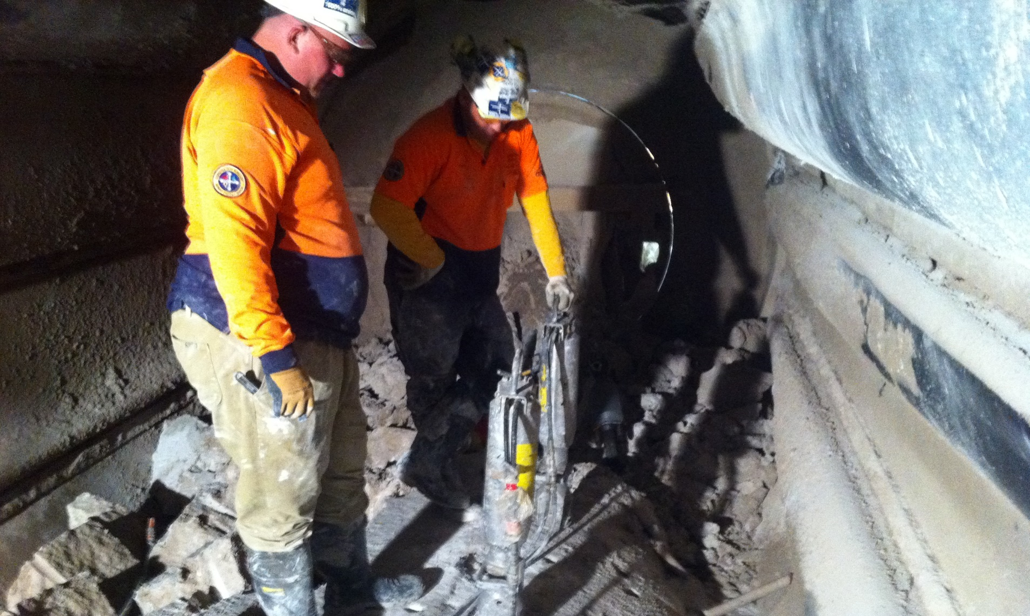
Incitec Pivot

Incitec Pivot

Service Focus
Solving the Problem with a Hydraulic Splitting and Bursting System.
Client: Incitec Pivot

Location: Incitec Pivot, North Geelong

Services Utilised: Hydraulic Bursting and Splitting, Core Drilling

Project Date: 2012

The Project:
When a major company's production of fertiliser was disrupted due to an adverse chemical reaction resulting in 12 to 14 ton of fertiliser product setting hard within its vessel which also affected the production of other product lines, Incitec Pivot's Process Manager, Peter Maurer, contacted Super City Concrete Cutting to quickly resolve the problem.
An adverse chemical reaction solidified 12-14 ton of fertiliser product within its vessel While Incitec had a procedure in place to rectify the problem, it was proving very expensive and time consuming.
Initially, the decision was made to drill a series of holes into the product at 500mm centres and fill these holes with an expandable grout. This type of process is effective in certain circumstances but on this occasion was not producing the expected results.
Supercity were then engaged to use hydraulic splitting and bursting systems to break up the fertiliser product.
The expandable grout process works on a chemical reaction which expands its mass and volume once water is mixed with it.

The increase in volume within the mass of material causes internal forces to expand causing fractures and faults within its mass.
Although the expandable grout did crack the material it did not provide a solution for extracting the material.
Incitec site operators tried using 90 pound air jack hammers to break down the mass of material with limited results. Based on what had been achieved so far a review to expedite the work and get the plant back on line was needed.

Solving the Problem with a Hydraulic Splitting and Bursting System:

After reading an article Incitec read on our web site involving hydraulic splitting and bursting systems, Peter Maurer contacted us directly.

I explained to Peter Maurer the operation requirements of the Darda System and more importantly what the system is designed to achieve.

Based on these discussions we trialed the procedure to see if the splitting system could process the material faster than current methods in place.

Prior to starting the trial we explained to Incitec that some limitations with the material cast inside the vessel may exist. As the fertiliser material had lower compression strength (mpa) than normal concrete the effectiveness of the darda splitting system may be reduced.

Drilling Access Holes for the Darda Trial:
Our operators completed a series of access holes for the darda cylinders using 48mm diamond core bits to a depth of 600mm.
Core holes were drilled in line at 500mm centres to the free edge of the material mass.
We were surprised at how hard the fertiliser product had set and realised the problems Incitec were facing trying to use 90 pound air hammers on this material.
Once the trial line of holes was completed we inserted 2 x C9 darda splitters and applied the pressure to the system. The result was very pleasing as it cracked and opened up the material to the size and shape we had planned. We were then able to move and shift different areas of material using darda combi shears with a lifting rate of 6000kg.
Managing Safety: Confined Space Entry:
Essentially the major issues and safety concerns were accessing the work area within the processing dryer. The dryer is a horizontal cylindrical vessel 8m long with a diameter of 2.5m.

Incitec Pivot

Access into the dryer vessel is limited to a single entry inspection door 700mm wide x 1600mm high. Breaking the hardened material into large chunks for manual removal

The Limited access also created issues with handling and removing the material once it had been Broken into manageable sizes. It was decided that the removal of the material would need to be lifted and removed by manual labour as the safest solution to clearing the mass of material inside the dryer vessel,

Co-ordinating a Rotating Production Line:
A splitting pattern was designed to break the material into manageable sizes that would assist in the manual labour required to shift the product. Unfortunately, the work that had been undertaken prior with the expandable grout created additional issues in terms of the way the material was breaking.
The major difference in application between expandable grout and a hydraulic system is very straight forward. When using a grout based product you undoubtedly end up with a star-burst effect resulting in cracks that spread in several different directions.
With hydraulic systems you can determine splitting/bursting patterns by the direction the cylinders are place into the pre drilled holes.
breaking up the material The majority of the mass section of material had been cracked through the expandable grout process. This meant that regardless of the hole patterns we were trying to create the effect of the darda systems would always follow the cracks created by the expandable grout.
This resulted in somewhat larger sections of material being created than what was desired. The Incitec operators were then left with the task to utilise the 90 pound hammers with greater effect as the back of the material had been broken and they were no longer hammering into masses of material that was absorbing the blows of the air hammers.
The Incitec operators completed a very labour intensive and challenging removal of the material inside the dryer vessel. A system of work was designed between Super City and Incitec that provided an efficient work plan to extract the material.
A rotation plan of work was designed to provide a safe work method between our operators and Incitec operators.
There was not enough room in the confined space to operate our equipment safely and extract the material at the same time.work shifts were required to remove the material safely
Work shifts were set in place between Super City and Incitec so the material
could be broken into manageable sizes and then removed without both parties working on top of each other.
This system enabled both entities to work through a difficult removal process and was completed safely and well ahead of what may have been required if the Darda Systems were not used.

Facts and Figures:

30 Man hours to complete core drilling and splitting of material x 3 operators

350no x 48mm core holes x 600mm deep

36 man hours to manually remove 12000kgs of material x 4 operators

Dryer back on line without damage to existing internal rubber protection lining

Equipment Used:
- Darda C9 hydraulic cylinders and electric power packs
- Darda Combi shears HCB6
- Weka DK16 hand held core drills
- Tyrolit 48mm diamond core bits fitted with B57 segments
- Three phase power supply

