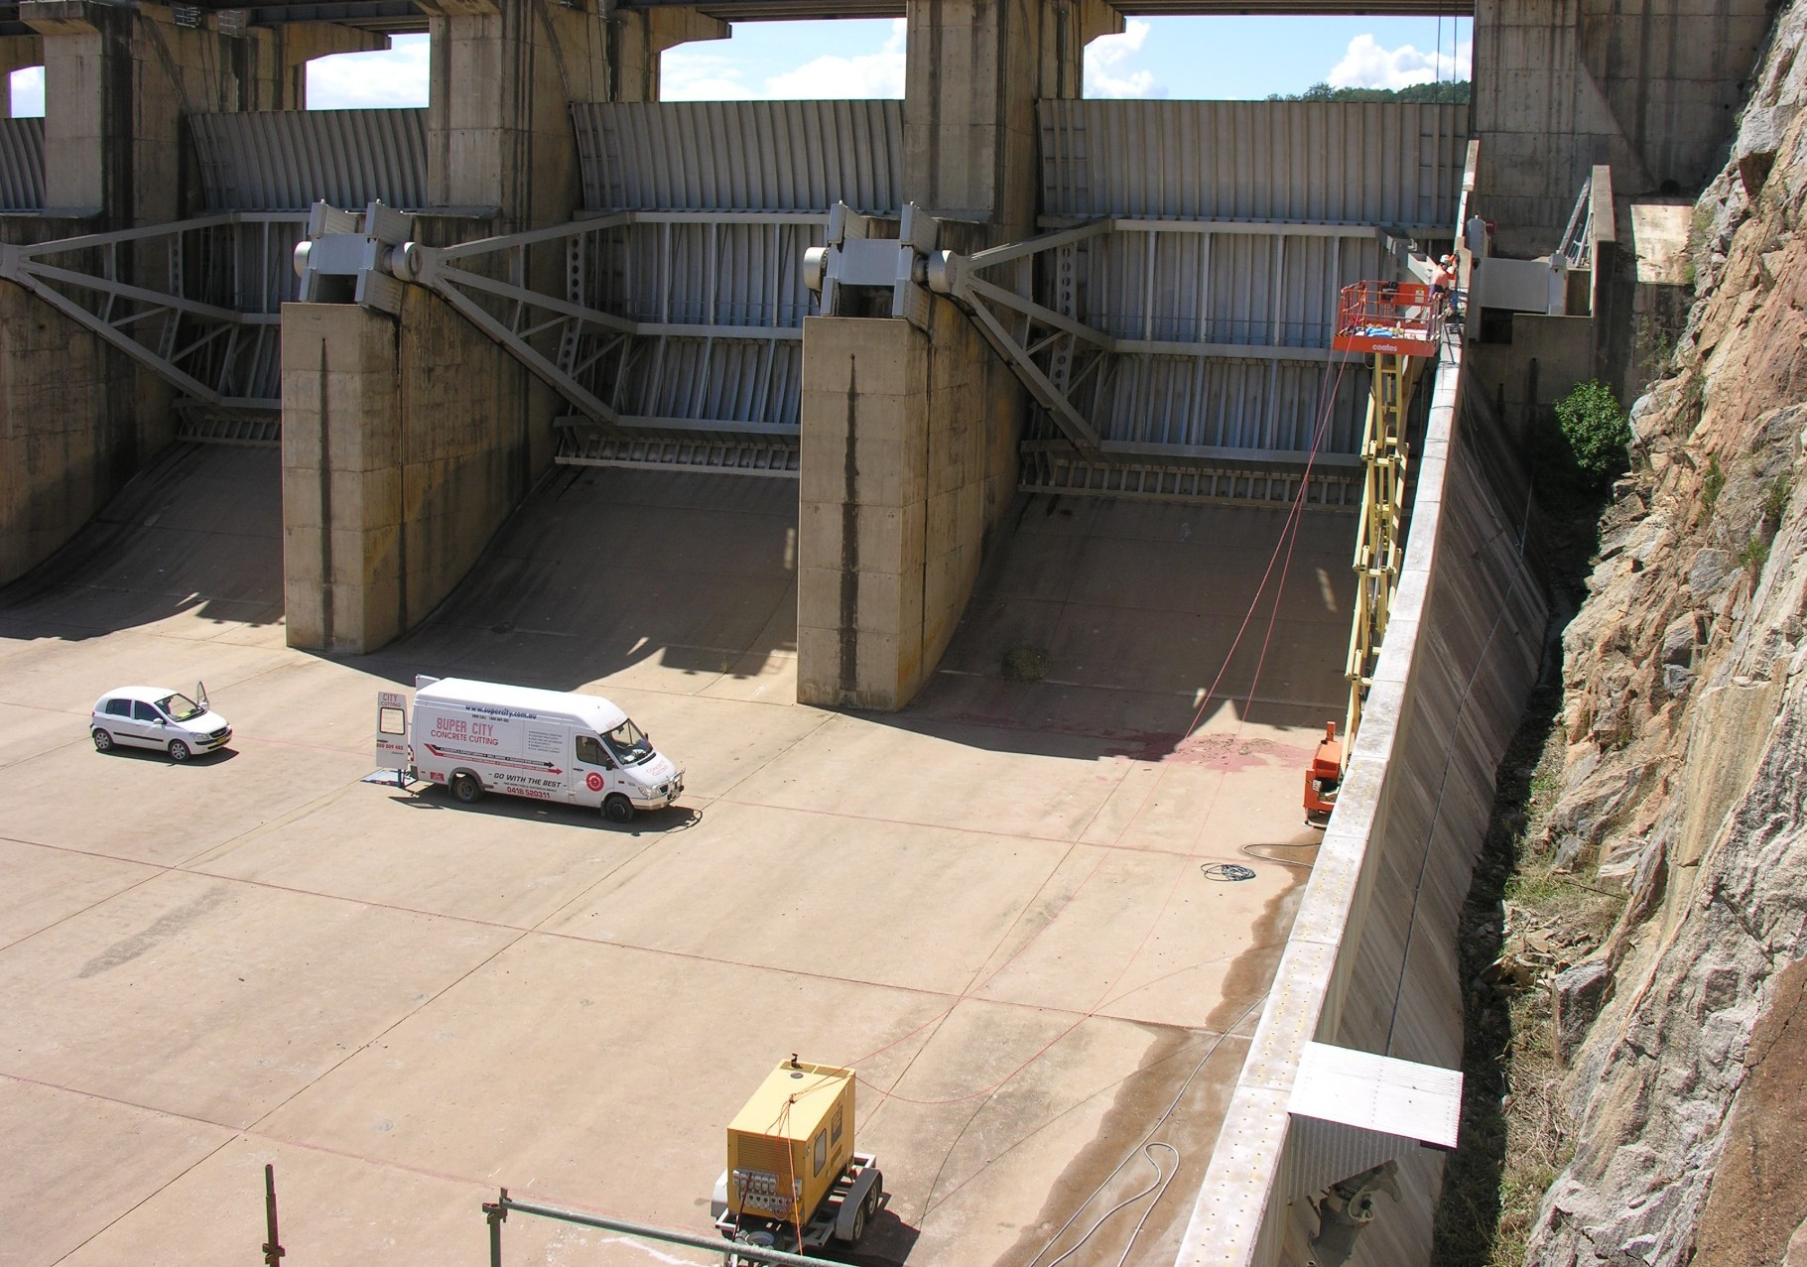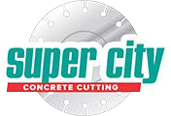Wyangala Dam Cowra
Wyangala Dam Cowra

Service Focus
Supercity primarily engaged to provide core drilling for chute wall extensions.
Client: REED Construction Group
Contractor: REED Construction Group
Location: Wyangala Dam, NSW
Services Utilised: Core Drilling, Sawing
Project Date: 2010

Reference for our work at Wyangala Dam from the REED Group:
"Jason Franken and his team from Super City Concrete Cutting were engaged in Reed Group's Wyangala Dam NSW Stage 1B Spillway Chute Wall Raising Project during March and April 2010. Super City's involvement was in fixed sump lump sum works primarily in core drilling large quantities of holes up to 60mm diameter to depths of up to 1000mm for placement of starter bars for the chute wall extensions either side of the Wyangal Dam Spillway.

The work was difficult in nature due to all works being at heights from 6m to 15m from the spillway slab, with the main access via boom lift or scissor lift. Super City was easy to manage, with OHS and quality compliance excellent at all times. When issues were raised requiring Super City's attention, they acted promptly and with courtesy.
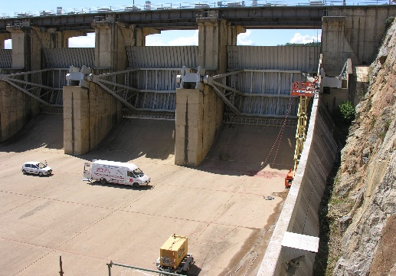
Some variations to the original work scope arose during the execution of the works, and discussions and determinations on quantities and values were open and honest.

In the administration of their contract with us, we encountered no difficulty or dispute, and issues were dealt with in good time.
The Project
Super City Concrete Cutting were engaged by Reed Group for the Wyangala Dam NSW Stage 1B Spillway Chute Wall Raising Project, during March and April 2010. Super City's involvement was in fixed sump lump sum works primarily in core drilling large quantities of holes up to

60mm diameter to depths of up to 1000mm for placement of starter bars for the chute wall extensions either side of the Wyangala Dam Spillway.
The work was difficult in nature due to all works being at heights from 6m to 15m from the spillway slab, with the main access via boom lift or scissor lift.
“I have no difficulty recommending Super City Concrete Cutting to any organisation or individual requiring the services they offer, and wish them well in the ongoing development of their business. Should the need arise, Reed will have no hesitation in offering Super City the opportunity to tender further works on this or other projects."
Christine Devane, Project Manager Wyangala 5/5/2010

www.supercity.com.au
Victoria
Phone: 03 5248 8009
Fax: 03 5248 8010
Mail: PO Box 302 Ocean Grove, 3226 Victoria
Northern Territory
Phone: 08 8941 5833
Fax: 08 8941 9633
Mail: PO Box 3022 Darwin, 0801 N.T.

