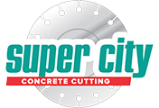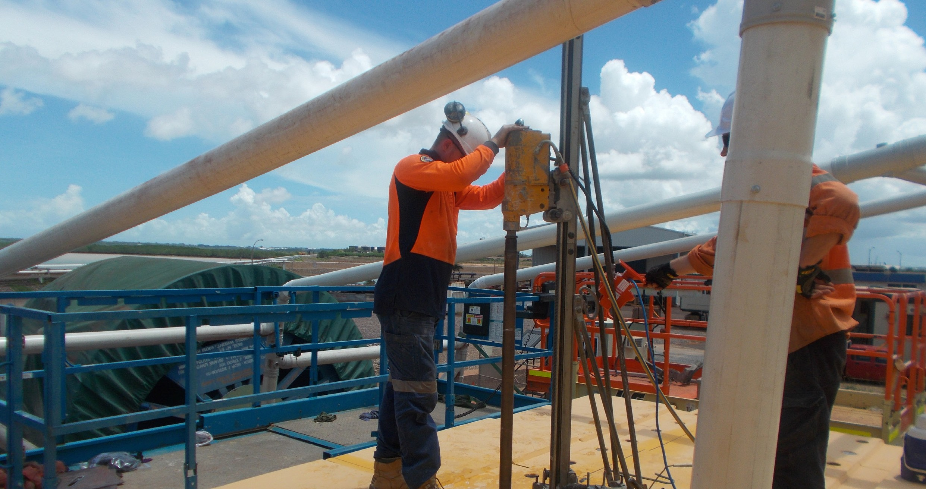
Mandorah Jetty

Mandorah Jetty, Dorwin NT

Service Focus

Tight Work Upgrading Mandoroh Jetty in Darwin.

Client: Port of Darwin
Contractor: Wolpers Grahl / DEC Projects

Project Manager: Alan Eckert

Contract Type: Cathodic protection to underside of existing Mandorah Jetty

Location: Mandorah Jetty, Darwin NT

Project Date: Sep 2011

Services utilized: Track Sawing

Purpose:
The structural integrity of the concrete jetty has been monitored over a number of years with vulnerable areas being fitted with Cathodic Protection to enhance the asset’s serve life. A recent survey of the jetty indicated further Cathodic Protection was required to ensure
the structural integrity of the jetty. Super City was subcontracted to cut a slot 10mm wide and 50mm deep to the underside of the jetty surface.

What is Cathodic Protection:
Cathodic Protection (CP) is a technique used to control the corrosion of a metal surface by making it the cathode of an electrochemical cell.
The simplest method to apply CP is by con- necting the metal to be protected with another more easily corroded “sacrificial metal” to act as the anode of the electrochemical cell.An- other method of protection impresses a small direct current on a structure Cathodic Protec- tion Systems are used to protect a wide range of metallic structures in various environments.

Common applications are:
- steel water or fuel pipelines storage tanks
- steel pier piles
- ships and boats
- offshore oil platforms and onshore oil well casings
- and metal reinforcement bars in concrete buildings and structures.

Best results indicated that the overage underside cover was around 60mm from the existing reinforcing layers
Procedure:
Super City Concrete Cutting supplied a WX15 track saw and a custom built blade manu- factured by Tyrolit Australia to complete the works.
- A series of 10mm wide x 50mm deep slots were cut using the track saw system to provide access for the cathodic protection.
- 280 lineal meters of inverted sawing 10mm wide x 50mm deep was completed on the jetty so the cathodic protection could be installed.
- The start of the jetty structure from waters edge proved most challenging as the ac- cess area to the underside of the jetty was only 650mm high.

- Operators worked their way through setting up the track in very tight areas, suc- cessfully aligning the track so all specified tolerances were achieved.

Safety:
Due to the restricted work area safety blade guards that are normally fitted to the unit could not be fitted This safety issue was identified prior to work commencing and a safe work method statement was complied and present- ed to the client for approval. The ability to re- mote control the track saw from a safe working distance reinforced our capabilities to maintain a safe work environment for this section of the work.

Project Completion:
The inverted sawing took 4 days to complete, providing the client with sufficient time to install the cathodic protection and grout in the electrical knes. Wolpers Grahl had not before seen a track saw used in this type of application and was very pleased with its versatility and production rates.
Stage 2 of this project will take place in the near future and we are looking forward to working together on the next phase of the upgrade.

